# **PostgreSQL 17 Performance Tuning: How to Find, Kill, and Analyze Long-Running and Blocked Queries**

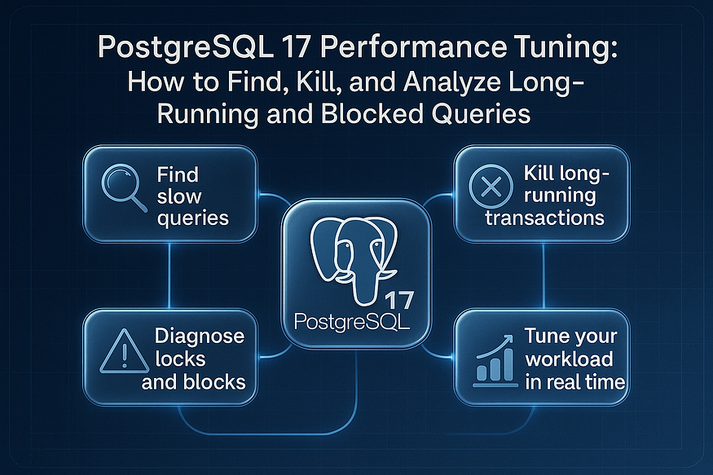

Keeping your PostgreSQL database fast, efficient, and healthy isn’t magic — it’s all about ****proactive monitoring****.

PostgreSQL provides a rich set of internal system views that act like windows into the database engine. If you’re managing production workloads, two of the most powerful views you should get comfortable with are:

* pg_stat_activity
* pg_locks

Together, these views can help you:

✅ Identify slow or stuck queries  
✅ Terminate runaway sessions  
✅ Understand locking behavior  
✅ Tune performance bottlenecks in real time

Let’s break this down.

## **🔍 What is**pg_stat_activity**?**

pg_stat_activity shows ****current activity in the PostgreSQL database****. It reveals what's running, who's running it, from where, and how long it's been running. It’s your go-to view for live session diagnostics.

****Sample Query:****

SELECT pid, usename, application_name, state, query, wait_event_type, wait_event, backend_start, query_start  
FROM pg_stat_activity  
WHERE state != 'idle'  
ORDER BY query_start;

****Key columns:****

* pid: Process ID of the backend
* usename: Connected user
* state: e.g., active, idle in transaction, etc.
* query: The actual SQL text being executed
* wait_event_type / wait_event: Useful to detect what it's waiting on (e.g., I/O, lock)

****Why it matters:****  
This view tells you ****who is doing what, for how long, and where the database is waiting****. For instance, spotting a query running for 25 minutes? That’s a likely candidate for tuning or termination.

## **🛠 Killing a Long-Running Query**

Sometimes you need to take action.

SELECT pg_terminate_backend(<pid>);

Use with care: this forcefully ends the session. A safer option for idle-in-transaction sessions is:

SELECT pg_cancel_backend(<pid>);

## **🔒 What is**pg_locks**?**

pg_locks provides visibility into all ****row-level, relation-level, and transaction-level locks****. It is invaluable when you're facing ****blocking issues**** or ****deadlocks****.

****Sample Query to View Blocking:****

SELECT blocked.pid AS blocked_pid,  
 blocked.query AS blocked_query,  
 blocking.pid AS blocking_pid,  
 blocking.query AS blocking_query  
FROM pg_locks blocked_locks  
JOIN pg_stat_activity blocked ON blocked_locks.pid = blocked.pid  
JOIN pg_locks blocking_locks ON blocking_locks.locktype = blocked_locks.locktype  
 AND blocking_locks.database IS NOT DISTINCT FROM blocked_locks.database  
 AND blocking_locks.relation IS NOT DISTINCT FROM blocked_locks.relation  
 AND blocking_locks.page IS NOT DISTINCT FROM blocked_locks.page  
 AND blocking_locks.tuple IS NOT DISTINCT FROM blocked_locks.tuple  
 AND blocking_locks.transactionid IS NOT DISTINCT FROM blocked_locks.transactionid  
 AND blocking_locks.classid IS NOT DISTINCT FROM blocked_locks.classid  
 AND blocking_locks.objid IS NOT DISTINCT FROM blocked_locks.objid  
 AND blocking_locks.objsubid IS NOT DISTINCT FROM blocked_locks.objsubid  
 AND blocking_locks.pid != blocked_locks.pid  
JOIN pg_stat_activity blocking ON blocking_locks.pid = blocking.pid  
WHERE NOT blocked_locks.granted;

****Use case:****  
If users are complaining that their transactions are “stuck,” this view shows ****who is blocking whom****, letting you trace and resolve the issue.

## **⚙️ Putting It All Together**

When performance issues strike, running a quick check on these views can save hours of debugging. Imagine this:

1. Check pg_stat_activity to find long-running queries
2. Use pg_locks to detect if they’re being blocked
3. Resolve the blocker using pg_cancel_backend() or pg_terminate_backend()

These are ****essential DBA moves**** that separate reactive firefighting from strategic, high-impact database operations.

## **📘 Final Thoughts**

PostgreSQL gives you the tools — you just need to know where to look. pg_stat_activity and pg_locks aren’t just diagnostic tools; they are your ****real-time observability dashboard**** for PostgreSQL health and performance.

If you’re building production-grade PostgreSQL systems, start by mastering these two views.

## **🔍 PostgreSQL Statistics Collector 101: The Heart of Database Observability**

PostgreSQL isn’t just a powerful database engine — it’s also incredibly self-aware.

Behind the scenes, PostgreSQL continuously collects vital runtime metrics through its ****built-in statistics collector subsystem****. This subsystem is what makes PostgreSQL’s observability tools so powerful. Whether you’re tuning performance, debugging locks, or monitoring table usage, this is the engine doing the heavy lifting.

Let’s take a closer look at what the statistics collector does — and why every DBA should love it.

## **💡 What is the PostgreSQL Statistics Collector?**

The ****statistics collector**** is an internal PostgreSQL process that ****gathers and stores runtime information**** about the database system. This includes:

* 🔄 ****Query execution patterns****
* 📊 ****Table and index access frequency****
* ⚙️ ****Client connection and backend activity****
* 🧮 ****Lock contention and wait events****

This isn’t just about pretty dashboards — it’s foundational for ****query tuning, capacity planning, and performance troubleshooting****.

## **🧬 How It Works**

The collector constantly receives updates from the server processes and stores them in shared memory. These statistics are then made available through a rich set of system views (think: virtual tables). You can query these views just like any table using SQL.

The statistics data is reset either manually (e.g., via pg_stat_reset()) or when the database restarts, so it’s meant for ****short- to medium-term analysis****, not long-term historical tracking (unless you integrate with tools like Prometheus or pgBadger).

## **📖 Key System Views You Should Know**

Here are some of the most essential views provided by the statistics collector:

### **🔎**pg_stat_activity**: Real-Time Query Monitoring**

Shows all current connections and the queries being executed. Crucial for detecting long-running or blocked queries.

SELECT pid, usename, query, state, query_start FROM pg_stat_activity WHERE state != 'idle';

### **🔒**pg_locks**: Lock Tracking**

Provides insights into what locks are held or waiting. Essential when diagnosing deadlocks or performance issues due to contention.

SELECT * FROM pg_locks WHERE NOT granted;

### **📊**pg_stat_database**: Global Stats Per Database**

Shows aggregate statistics at the database level — tuples fetched, committed, rolled back, blocks hit, and more.

SELECT datname, numbackends, xact_commit, blks_hit FROM pg_stat_database;

### **🧮 Other Useful Views:**

* pg_stat_user_tables: Stats per user table (e.g., seq scans, inserts, updates)
* pg_stat_user_indexes: Index usage patterns (e.g., idx scans, idx fetches)
* pg_statio_user_tables: I/O patterns (heap reads, blocks read vs. hit)
* pg_stat_bgwriter: Background writer activity (checkpoints, buffers written)

These views give DBAs and developers an ****x-ray view of what’s really happening**** inside their PostgreSQL database.

## **🔧 Why It Matters**

Without the statistics collector:

* You’d be ****guessing at performance issues****
* You couldn’t ****optimize queries based on real usage****
* You’d have no visibility into ****locks, deadlocks, or wait events****
* Scaling decisions would be ****blind bets****

With it, however, you get a ****powerful toolkit**** to guide indexing strategies, rewrite inefficient queries, manage connection pooling, and stay ahead of potential bottlenecks.

## **📌 Final Thoughts**

The PostgreSQL statistics collector is the unsung hero behind every tuned query and every well-optimized system. By exposing real-time and cumulative performance data, it allows DBAs, developers, and SREs to make ****data-driven decisions**** instead of relying on gut feeling or guesswork.

So the next time you’re chasing down a slow query or planning to scale your infrastructure, start by querying the stats. PostgreSQL already has the answers — ****you just need to ask the right views.****

## **🎯 Monitoring Queries with**pg_stat_activity

When you’re managing a PostgreSQL database — especially in a production environment — ****real-time visibility into what queries are running**** is absolutely critical.

That’s where pg_stat_activity comes in.

This powerful system view gives you a ****live snapshot of all active connections**** to your PostgreSQL instance. Whether you’re investigating a performance slowdown, tracking suspicious behavior, or simply monitoring user activity, pg_stat_activity is your go-to tool.

## **📸 What is**pg_stat_activity**?**

pg_stat_activity is a ****system catalog view**** that shows information about:

* All current client connections
* The state of each backend (e.g., active, idle)
* The SQL statement being executed
* When the query started
* Who issued it and from where

Think of it as ****PostgreSQL’s process list**** — a real-time dashboard of database activity at the session level.

## **📄 View All Running Queries**

To get the full picture of what’s happening in your database, this is the simplest and most informative starting point:

SELECT * FROM pg_stat_activity;

This query returns details such as:

* pid: Process ID of the session
* usename: Username of the connected client
* datname: Database name
* client_addr: IP address of the client
* query: SQL being executed
* state: active, idle, idle in transaction, etc.
* query_start: When the current query started

💡 ****Tip:**** Focus on queries with long durations and those in active or idle in transaction states—they often indicate performance issues or open transactions that need attention.

## **🔢 Count Total Active Connections**

Want to see how many users are currently connected? Use this simple count query:

SELECT COUNT(*) AS total_conns FROM pg_stat_activity;

This is particularly useful for:

* ****Monitoring load**** on your PostgreSQL instance
* ****Enforcing connection limits****
* ****Detecting spikes**** during traffic surges or abnormal usage

You can also compare this number to max_connections in your postgresql.conf to ensure you're not close to hitting your connection ceiling.

## **🌐 Count Connections from a Specific IP**

Need to check if one particular client is overloading the server or making too many connections? Filter by IP:

SELECT COUNT(*) FROM pg_stat_activity WHERE client_addr = '192.168.1.10';

This query helps:

* Detect ****abuse or anomalies**** from a single source
* Enforce ****client connection policies****
* Debug issues tied to specific ****application servers****

You can even extend this query to group and rank IPs by the number of connections:

SELECT client_addr, COUNT(*) AS conn_count  
FROM pg_stat_activity  
GROUP BY client_addr  
ORDER BY conn_count DESC;

## **🚨 Common Use Cases for**pg_stat_activity

* 🔍 ****Identifying slow or stuck queries****
* 🧯 ****Killing long-running sessions**** via pg_terminate_backend(pid)
* 🧭 ****Tracing application behavior**** during incidents
* 📊 ****Monitoring resource consumption per user or application****

## **🧠 Final Thoughts**

pg_stat_activity is more than just a monitoring tool—it's a ****critical observability asset**** for PostgreSQL DBAs and developers. With a few simple SQL queries, you can diagnose bottlenecks, monitor live traffic, and take immediate action to ensure the health and performance of your database.

Next time something feels “off” with your database, start with pg_stat_activity. It often tells you exactly what you need to know.

## **🚩 Find Long-Running Queries in PostgreSQL**

When your PostgreSQL database starts feeling sluggish, one of the first culprits to investigate is ****long-running queries****.

These queries can:

* Hold locks for too long
* Block other transactions
* Consume CPU and memory
* Slow down overall system performance

The good news? PostgreSQL gives you the tools to ****catch them in real time****.

## **🕵️‍♂️ SQL to Catch Long-Running Queries**

Here’s a simple query that identifies any session where the query has been running for ****more than 5 minutes****:

SELECT  
 pid,  
 usename,  
 query_start,  
 now() - query_start AS query_time,  
 query,  
 state,  
 wait_event_type,  
 wait_event  
FROM pg_stat_activity  
WHERE now() - query_start > interval '5 minutes';

This query leverages the pg_stat_activity view to show everything about sessions that may be hogging resources.

## **📌 What You’re Seeing**

Let’s break down the important columns:

* ****pid****: Process ID of the session. You’ll use this with functions like pg_terminate_backend() to stop a query if needed.
* ****usename****: The database user who is running the query.
* ****query_start****: Timestamp when the query started.
* ****query_time****: How long the query has been running (calculated as now() - query_start).
* ****query****: The actual SQL text. This helps you understand what’s causing the issue.
* ****state****: Whether the session is active, idle, or idle in transaction.
* ****wait_event_type**** / ****wait_event****: Shows if the query is waiting on a lock, I/O, or another resource—great for diagnosing why it's stuck.

💡 ****Pro tip:**** If wait_event indicates something like Lock, the session might be ****blocked by another transaction****.

## **📊 See Database-Wide Activity Snapshot**

Want a ****big-picture overview**** of who’s connected to your PostgreSQL database, what databases they’re using, and what state their sessions are in?

This query provides a grouped summary:

SELECT  
 client_addr,  
 usename,  
 datname,  
 state,  
 COUNT(*)  
FROM pg_stat_activity  
GROUP BY client_addr, usename, datname, state  
ORDER BY COUNT(*) DESC;

## **📋 What This Shows You:**

* ****client_addr****: The IP address of the connecting client
* ****usename****: The database user
* ****datname****: The name of the database
* ****state****: Active, idle, idle in transaction, etc.
* ****COUNT(*)****: Number of sessions in this category

This view is ideal for:

* Monitoring ****connection patterns****
* Spotting ****overloaded applications****
* Understanding ****how many clients are connected and in what state****

For example, if you see a high number of idle in transaction connections from a specific IP, that could indicate a ****poorly managed connection pool**** or an app not committing its transactions.

## **🧠 Wrapping Up**

PostgreSQL provides deep introspection tools, and with just a few queries, you can:

* Find and fix long-running queries
* Monitor connection load and patterns
* Pinpoint performance bottlenecks

By mastering pg_stat_activity, you gain the visibility needed to maintain a ****healthy, performant database****—without guesswork.

Stay tuned for the next post, where we’ll dive into ****pg_stat_statements**** for historical query performance tracking!

## **🔒 Detect Locks and Blocked Queries in PostgreSQL Like a Pro**

When a PostgreSQL database starts slowing down and ****nothing obvious appears to be wrong****, there’s a good chance the issue is related to ****locks****.

Locks are essential for maintaining ****data consistency**** and ****transactional integrity****, but when mismanaged, they can silently wreak havoc on your system — causing delays, timeouts, and user frustration.

In this section, we’ll walk through how to detect and trace locks using pg_locks and identify blocked queries using pg_stat_activity.

## **🔍 Detecting Locks with**pg_locks

The PostgreSQL system view pg_locks gives you visibility into all types of locks held or awaited by sessions in the database. These include:

* Row-level locks
* Table-level locks
* Transaction-level locks

To view all currently held and waiting locks, run:

SELECT * FROM pg_locks;

This gives you low-level details, including:

* ****locktype****: The type of lock (relation, transaction, etc.)
* ****mode****: The kind of lock (e.g., RowExclusiveLock, AccessShareLock)
* ****granted****: Whether the lock is currently granted (true) or the process is still waiting for it (false)
* ****pid****: The process ID holding or waiting on the lock

## **🧾 Find Locks with Table Names**

Raw lock data is hard to interpret without knowing which ****tables**** are involved. Use this query to join pg_locks with pg_class and pg_stat_activity to get the ****table names and related queries****:

SELECT  
 relname AS relation_name,  
 query,  
 pg_locks.*  
FROM pg_locks  
JOIN pg_class ON pg_locks.relation = pg_class.oid  
JOIN pg_stat_activity ON pg_locks.pid = pg_stat_activity.pid;

This version gives you:

* ✅ Table name (relname)
* ✅ The ****SQL query**** responsible for holding or waiting on the lock
* ✅ All lock metadata from pg_locks

💡 This is especially useful when diagnosing ****contention on specific tables**** — such as when an UPDATE or DELETE operation is blocking other transactions.

## **🚦 Identify Blocked Queries and Their Blockers**

Want to find out which queries are blocked — and ****exactly who’s blocking them****? This powerful query shows both sides of the problem:

SELECT  
 activity.pid,  
 activity.usename,  
 activity.query,  
 blocking.pid AS blocking_id,  
 blocking.query AS blocking_query  
FROM pg_stat_activity AS activity  
JOIN pg_stat_activity AS blocking  
 ON blocking.pid = ANY(pg_blocking_pids(activity.pid));

## **📌 What This Tells You:**

* ****activity.pid****: The session that is currently ****blocked****
* ****activity.query****: The SQL query that is waiting
* ****blocking.pid****: The session that is ****causing the block****
* ****blocking.query****: The SQL query currently holding the lock

This is one of the most ****actionable diagnostic tools**** in PostgreSQL.

You can trace lock chains and:

* Notify or terminate the blocking session (pg_terminate_backend(pid))
* Optimize long-running write operations
* Rethink transaction scopes in your application

## **🧠 Why Locks Matter (And Why You Should Watch Them)**

* Locks are necessary, but when ****left uncommitted**** or ****poorly indexed****, they block critical operations.
* A single idle in transaction session can ****freeze a table**** for everyone else.
* The longer a lock waits, the more ****backpressure**** it puts on your entire system.

By actively monitoring pg_locks and blocked queries, you’ll keep your PostgreSQL environment responsive, reliable, and user-friendly.

## **✅ Final Thoughts**

Locks don’t have to be mysterious. With the power of pg_locks, pg_stat_activity, and smart queries, you can:

* Detect contention before users feel it
* Trace the root cause of blocking chains
* Take informed action to free up system resources

The next time you’re staring at a sluggish dashboard or stuck migration, check your locks. The problem — and the fix — might already be waiting for you in pg_stat_activity.

## **⚠️ Cancel or Kill Long-Running Queries in PostgreSQL**

In any PostgreSQL system — especially those in production — ****long-running queries**** can become a major performance bottleneck. They can:

* Hold locks for extended periods
* Block other queries
* Consume memory and CPU
* Delay user-facing responses or batch jobs

When that happens, you may need to intervene and ****stop the query manually****. Fortunately, PostgreSQL provides two powerful tools to help: pg_cancel_backend() and pg_terminate_backend().

But the choice between the two matters — let’s break them down.

## **✅ Graceful Cancel (Preferred Method)**

If you want to ****stop the query but not disconnect the user session****, use the pg_cancel_backend() function. This method ****requests the server to cancel the currently running query****, allowing the client connection to stay open.

SELECT pg_cancel_backend(pid)  
FROM pg_stat_activity  
WHERE query LIKE '%your_problem_query%';

### **🔍 What It Does:**

* ****Attempts a clean interruption**** of the running query
* Leaves the session ****alive****, so the user or application can continue sending new queries
* Ideal for ****interactive sessions****, dashboards, or apps that you don’t want to fully disconnect

🧠 ****Pro Tip****: This is your ****first line of defense****. Always try canceling before resorting to a forceful termination.

## **🛑 Force Kill (Use with Caution)**

If canceling the query doesn’t work — or if the session is stuck in a bad state — you can escalate with pg_terminate_backend(). This ****immediately terminates the entire backend process**** handling the query.

SELECT pg_terminate_backend(pid)  
FROM pg_stat_activity  
WHERE query LIKE '%your_problem_query%';

### **⚠️ What It Does:**

* ****Kills both the query and the database connection****
* Rolls back any open transactions associated with the session
* Can be disruptive if the session is part of a larger transaction block or a connection pool

💥 ****Warning****: Use this method only when you’re certain the session ****must be terminated**** — such as in cases of deadlocks, runaway queries, or system-threatening behavior.

Press enter or click to view image in full size

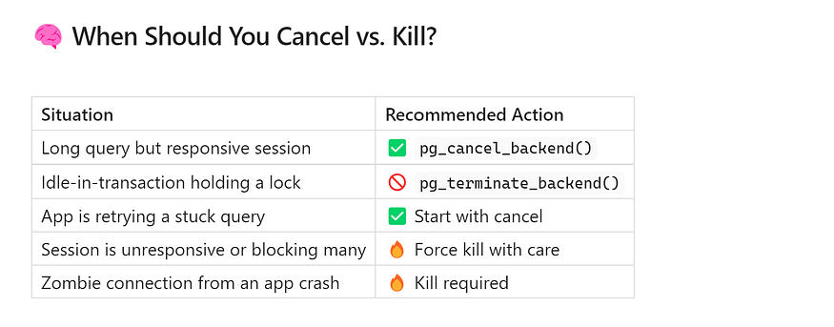

## **✅ Final Thoughts**

PostgreSQL gives you fine-grained control over managing queries — but with great power comes great responsibility. Understanding the ****difference between canceling and killing**** is key to maintaining stability without accidentally dropping active users or services.

Whenever possible:

* ****Start with cancel****
* ****Monitor lock wait events****
* ****Only kill when absolutely necessary****

And always log the actions you take, especially in production environments.

## **🖥 Use pgAdmin to Manage Queries — No SQL Needed**

If you’re managing PostgreSQL databases but don’t feel comfortable typing SQL commands — or you just prefer a visual interface — ****pgAdmin**** is your best friend.

****pgAdmin**** is the official graphical user interface (GUI) tool for PostgreSQL, and it makes monitoring and managing queries as easy as a few clicks. Whether you’re a beginner or a seasoned DBA looking for convenience, pgAdmin helps you avoid memorizing SQL commands for tasks like tracking queries, canceling problematic sessions, or terminating runaway connections.

Let’s walk through how to use it step-by-step.

## **🚀 Step-by-Step: Monitor and Manage Queries Using pgAdmin**

### **1️⃣ Open pgAdmin**

Launch pgAdmin on your local machine or access it via the browser if it’s hosted on a server. Log in with your credentials and connect to your PostgreSQL server instance.

### **2️⃣ Select Your Database**

In the ****left-hand tree panel****, expand the connection to your PostgreSQL server. Navigate to the database you want to monitor.

### **3️⃣ Go to: Dashboard → Activity → Sessions**

Once inside your selected database:

* Click on the ****Dashboard**** tab (top panel).
* Select the ****Activity**** tab.
* Choose ****Sessions**** to view a list of all current database sessions and queries.

This panel displays:

* Connected users
* Running queries
* Session states (active, idle, idle in transaction)
* Backend process IDs (PIDs)
* Application names
* Client IPs
* Query durations

### **4️⃣ Easily Sort, Cancel, or Terminate Queries**

From the Sessions panel, you can ****interact directly with any running query****:

* ✅ ****Sort by query duration**** to spot long-running processes
* ❌ ****Right-click → Cancel**** to gracefully stop a query
* 🔥 ****Right-click → Terminate**** to forcefully kill a session (use with caution)

This is especially useful when:

* You notice a query blocking others
* A user left a session open and it’s holding locks
* You want to free up system resources without writing SQL

## **💡 Why Use pgAdmin for Query Management?**

* ****No need to write or remember SQL commands****
* ****Visual clarity**** makes it easy to spot performance issues
* Ideal for ****quick interventions**** during incidents
* Great for ****non-DBAs**** who need to manage PostgreSQL occasionally

Whether you’re managing a development environment or troubleshooting production, pgAdmin offers a ****user-friendly alternative**** to command-line tools like psql.

## **✅ Final Thoughts**

pgAdmin puts powerful PostgreSQL monitoring tools right at your fingertips — no need to be a SQL wizard. With a few clicks, you can sort, cancel, and kill queries, giving you real-time control over your database sessions.

If you’re just getting started with PostgreSQL or managing multiple databases, integrating pgAdmin into your workflow can save time and reduce errors.

## **📊 Key Columns in**pg_stat_activity**— What They Mean and Why They Matter**

When you’re monitoring your PostgreSQL database using pg_stat_activity, it's essential to understand the meaning of the key columns. These fields give you valuable insights into what's happening inside your database at any given moment.

Here’s a breakdown of the most important columns you’ll encounter:

Press enter or click to view image in full size

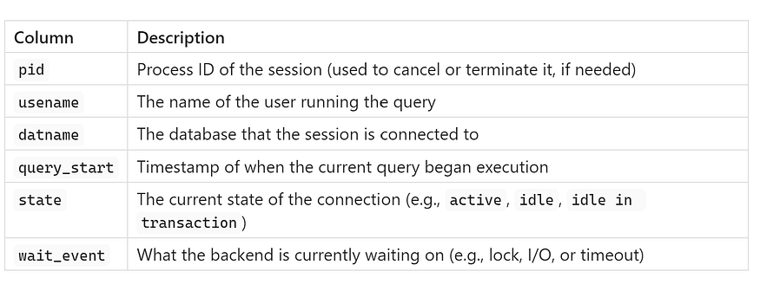

These columns are especially useful when diagnosing slow queries, connection bottlenecks, or blocked transactions.

## **🔎 Extra Monitoring Queries — Supercharge Your PostgreSQL Visibility**

Once you’re familiar with pg_stat_activity, you can start running targeted queries to get deeper insights. Here are some ****practical monitoring queries**** to help you stay ahead of issues:

## **✅ View All Active Connections**

SELECT * FROM pg_stat_activity;

This is your general-purpose snapshot of all current sessions, including users, IPs, queries, and more. Use this as a starting point to understand overall activity.

## **🔢 Count Total Connections**

SELECT COUNT(*) FROM pg_stat_activity;

This gives you a quick total of all current sessions. It’s useful for:

* Monitoring system load
* Spotting connection pool issues
* Ensuring you’re within limits of max_connections

## **🚦 Find Queries That Are Waiting**

SELECT * FROM pg_stat_activity   
WHERE wait_event IS NOT NULL   
AND backend_type = 'client backend';

This filters out any backend processes that are ****waiting on something**** — typically due to locks or I/O delays. This is a powerful way to identify:

* Blocked queries
* Lock contention issues
* Queries stuck due to resource unavailability

🧠 ****Tip:**** Combine this with lock-tracing queries for deeper diagnostics.

## **⏱ Find Queries Running for Over 1 Second**

SELECT  
 client_addr,  
 usename,  
 datname,  
 now() - query_start AS query_age,  
 state,  
 query  
FROM pg_stat_activity  
WHERE (now() - query_start) > interval '1 second'  
AND state <> 'idle'  
ORDER BY query_start;

This helps you catch ****long-running or suspiciously slow queries****, even if they aren’t holding locks. It’s great for spotting:

* Performance bottlenecks
* N+1 query problems
* Queries not using indexes effectively

📌 Focus on queries with high query_age and non-idle states for optimization opportunities.

## **🧠 Final Thoughts**

Understanding and using pg_stat_activity effectively is a game-changer for PostgreSQL monitoring. By mastering its key columns and combining them with powerful query patterns, you can:

* Monitor active sessions in real time
* Detect and resolve performance issues faster
* Ensure your system stays responsive and stable

The beauty of PostgreSQL is that it offers ****deep introspection tools**** without needing any external add-ons. With just SQL and a bit of know-how, you’re already in control.

## **🔁 Advanced Lock Chain Visualization in PostgreSQL**

****Unravel complex deadlocks like a pro****

When you’re dealing with PostgreSQL performance issues, sometimes it’s not enough to just see which queries are blocked — you need to understand ****how the blocking chain unfolds****. This is especially important in complex environments where ****multiple sessions block each other in cascading sequences****, potentially leading to deadlocks.

That’s where this ****recursive lock chain visualization query**** becomes your secret weapon. It gives you a ****tree-like view**** of who is blocking whom — and how deep the blockage goes.

## **🧠 Why You Need This**

In real-world workloads:

* One user might be waiting on a lock held by another.
* That second user might be waiting on a third.
* Before you know it, you’re in a ****multi-level lock chain**** or even a deadlock.

This recursive query helps you trace that chain ****step-by-step****, making it easier to pinpoint the root blocker and clean up the jam.

## **🔍 What This Query Does**

Here’s what each part of the query is doing:

### **🔄**WITH RECURSIVE l AS (...)

This part prepares a list of ****locks****, capturing key lock identifiers like relation, page, transactionid, etc., and wraps them into a structured obj row. This makes it easy to compare locks later.

### **🔗**pairs AS (...)

This builds ****waiter → locker pairs****. It checks which sessions are ****waiting**** on the same lock object that is ****already held**** by another session. It filters out self-pairs and ensures only ****granted vs. waiting**** locks are linked.

### **🌳**tree AS (...)

This is the heart of the recursion. It:

* Starts with the ****root blockers**** — sessions that are ****not being blocked**** by anyone.
* Then recursively adds all sessions that are ****waiting on these blockers****.
* Builds a path (1.2.3) and level (lvl) to form a visual tree structure.
* Prevents cycles using an ARRAY to track seen PIDs.

## **📤 Final Output: A Visual Blocking Chain**

SELECT  
 (clock_timestamp() - a.query_start)::interval(3) AS query_age,  
 a.datname,  
 tree.pid,  
 a.usename,  
 a.client_addr,  
 lvl,  
 REPEAT(' .', lvl) || ' ' || LEFT(REPLACE(query, E'\n', ' '), 80) AS query  
FROM tree  
JOIN pg_stat_activity a USING (pid)  
ORDER BY path;

### **🧾 What You’ll See:**

Column Description query_age How long the query has been running datname Database name pid Process ID of the session usename User running the query client_addr IP address of the client lvl Level in the blocking tree (0 = root blocker) query Truncated, formatted SQL query with indentation based on tree level

Indentation (REPEAT(' .', lvl)) visually illustrates which sessions are ****blocking others**** and how deep the chain goes.

## **🧰 When to Use This**

Use this recursive query when:

* You suspect a ****deadlock**** or ****multi-session blocking****
* A single long-running transaction is blocking ****dozens of others****
* You need to ****identify the root blocker**** for resolution
* You want to ****visualize query dependencies**** during peak loads

It’s incredibly useful in ****OLTP systems****, batch data loads, or any environment with heavy write contention.

## **✅ Final Thoughts**

This recursive query is like having ****x-ray vision**** into PostgreSQL’s lock mechanics. While tools like pg_locks and pg_stat_activity give you the pieces, this view ****connects the dots**** and reveals the full lock chain in one elegant output.

Whether you’re debugging a production incident or proactively tuning performance, mastering lock chain visualization sets you apart as a PostgreSQL expert.

## **🏁 Conclusion: Master Your PostgreSQL Like a Pro**

Managing a high-performing PostgreSQL database isn’t just about reacting to problems after they occur — ****it’s about staying ahead of them****.

The good news? PostgreSQL gives you everything you need to do just that.

## **✅ Real-Time Visibility, Right at Your Fingertips**

PostgreSQL’s introspection tools, like pg_stat_activity and pg_locks, provide ****live insights into the heart of your database****. You don’t need to guess which query is slow, which user is blocked, or where contention is happening—PostgreSQL tells you.

From query durations to session states and lock conflicts, these tools let you:

* ****Track real-time activity****
* ****Spot bottlenecks early****
* ****Act before users notice a problem****

## **✅ Master**pg_stat_activity**and**pg_locks

These two system views form the ****core of any PostgreSQL monitoring strategy****.

* Use pg_stat_activity to find ****long-running or stuck queries****, track user behavior, and monitor session health.
* Use pg_locks to ****trace lock contention****, identify deadlocks, and map blocking chains with advanced queries.

Together, they give you ****360° control over query behavior and system performance****.

## **✅ Go Beyond Queries: Build Dashboards and Alerts**

Don’t stop at manual monitoring — ****automate your visibility****:

* Integrate with tools like ****Grafana****, ****Prometheus****, or ****pgBadger**** for visual dashboards
* Set up ****alerting**** when queries run too long, lock chains form, or connection limits are reached
* Use scheduled jobs or background workers to ****log and audit activity patterns****

This shifts you from ****reactive**** DBA work to a ****proactive performance guardian****.

## **🚀 Final Thought: Prevention is the New Cure**

The best DBAs don’t just fix problems — they ****prevent them****.

By mastering PostgreSQL’s built-in monitoring features, you’ll gain:

* Faster diagnostics
* Smoother operations
* Happier end users
* Fewer 2 AM incident calls

PostgreSQL is more than a database engine — it’s a platform that empowers you to run stable, high-performance systems. All you need to do is ****tap into the visibility it already provides****.

👉 *If you found this guide helpful, follow me(****medium****) for more practical*